**Breaking System**

**Research Analysis**

**Vehicle Dynamics Department**

**University of Salford Race Team**

**Introduction**

This report is to give an overview of how the braking system works and the theory behind it. It is also to ensure we meet the regulations of the ruling on the braking system noted in the FSAE rules 2018.

**Theory**

The basic theory of the braking system is that when you apply a force to the brake pedal they use hydraulics which is a system of fluid filled pipes used to multiply the force enough to require the car to slow down. This is used as the force applied from the pedal will not be great enough.

When you press on the brake pedal, your foot moves a lever that forces a piston into a long, narrow cylinder filled with hydraulic fluid. As the piston plunges into the cylinder, it squirts hydraulic fluid out through a long and narrow pipe at the end. The pipe feeds into much wider cylinders positioned next to the car's four brakes. Because the cylinders near the brakes are much wider than the one near the brake pedal, the force you originally applied is multiplied greatly, clamping the brakes hard to the wheels.

Here is a basic diagram of it in use



**Rules:**

* The car must have four wheel brakes operated by a single control.
* It must have two independent hydraulic circuits with independent fluid reserves
* The brake system must be capable of locking all four wheels, and stopping the vehicle in a straight line
* The braking system must be protected with scatter shields from failure of the drive train
* A brake pedal over-travel switch must be installed. This switch must kill the ignition and cut the power to any electrical pumps.
* The car must be equipped with a red brake light that illuminates whenever the brakes are applied

Here I picked out the key rulings for the braking system. There are other to look over in the overall ruling guide.

**Part break down**

* Brake pedal
* A push rod
* Master cylinder assemble ( piston, return spring and fluid reservoir
* Hydraulic lines
* Brake pads

These are the basic parts needed to assemble the brake system. When looking at last years research it is believed we will be able to use most stuff off of the quad and purchase the following part.

Cylinder buy link]    3/4 size 2x    http://www.demon-tweeks.co.uk/motorsport/brake-master-cylinders-reservoirs/wilwood-compact-integral-reservoir-master-cylinder

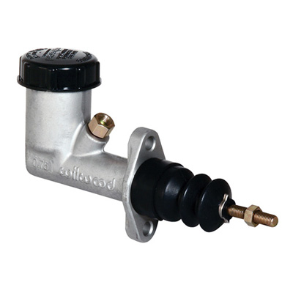

There is an excel sheet on the google drive which includes all the braking calculations which gives a very good brake down. It also lets us now that in theory the braking system will work.

**Conclusion**

A quick conclusion of this report is that the braking system calculations have been done and they all point to it working fine and stopping in a straight line. One thing I need to do is next Wednesday in the aero lab find out what part are on the quad and see if we are definitely able to use them and that they are compatible with the part we will purchase. If we find they are not then either change the purchased part or we will have to look into getting other compatible parts.